Q1.

DFD of Safe-Bernard application

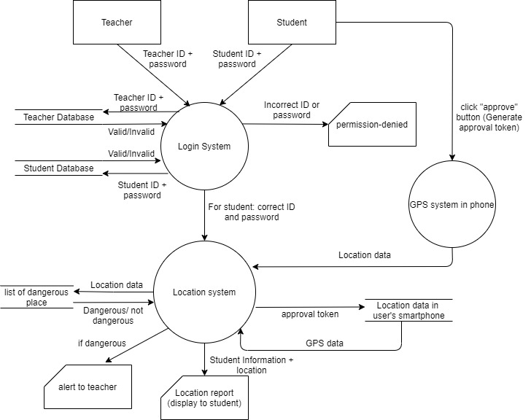

Q2.

UML activity diagram of reading a research paper

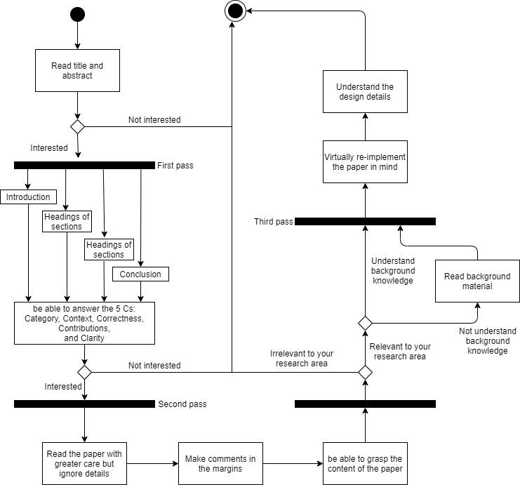

Q3(a)

FSM of cleaning robot

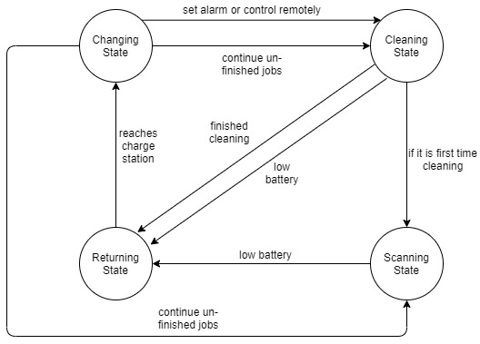

Q3(b)

Advantage: The FSM is simple and easy to understand. Also, the FSM states clearly how the robot change from a state to another state.

Disadvantages: The FSM is synchronous model, so it is difficult to determine which state is the initial state. Moreover, it is difficult to determine which input is going to be performed. For example, in the changing state, it is difficult to determine whether set alarm or continue unfinished jobs is performed. In conclusion, in a specific time, users difficult to determine which state the robot is.

Q4(a)

FSM of Alice’s song

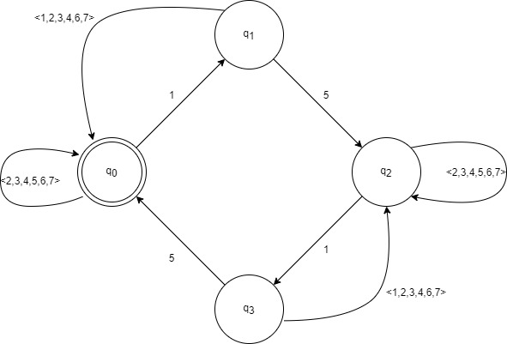

q0 is the initial state and the final state. q1, q2 and q3 are other states.

Specifically, q1 is the state after accepting an input of 1 from q0.

q2 is the state after accepting an input of 5 from q1.

q3 is the state after accepting an input of 1 from q2.

How the FSM works:

Note that a song that contains the pattern “15” an even number of times satisfy the above FSM. Initially, the state is q0. When user input a pattern of “15”, the state will become q2. When user input a pattern of “15” again, the state will become q0 which is the final state. So, if user input the pattern “15” even number of times, it will always go back to the final state q0.

If the song does not contain the pattern “15” an even number of times, the final state can never be q0. It is because the input causes the state to go back to itself. In state q0, if user input a number except 1, it goes back to q0, so the song still satisfies the requirement. In state q1, if user input a number except 5, it goes back to q0, so the song still satisfies the requirement. In state q2, if user input a number except 1, it goes back to q2, so the song does not satisfy the requirement. In state q3, if user input a number except 5, it goes back to q2, so the song does not satisfy the requirement.

We conclude the above FSM works.

Q4(b)

FSM of Alice’s new song

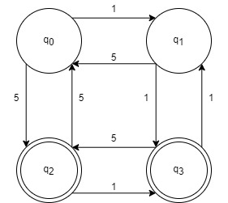

q0 is the initial state. q2 and q3 are final states. q0 is other state.

How the FSM works:

The song satisfy condition (a) should be in the final state q3. The song satisfy condition (b) should be in the final state q2.

Consider condition (a), the sequence of notes ends with “1” should contain an even number of digits. So, the above FSM should make even state changes to end in state q3. For example, “11”, “51”. Also, there should be two input “1” from different states to state q3. Then we can construct the FSM as above.

Consider condition (b), the sequence of notes ends with “5” should contain an odd number of digits. So, the above FSM should make odd state change(s) to end in state q2. For example, “5”, “115”, “155”. Also, there should be two input “5” from different states to state q2. Then we can construct the FSM as above.